OT/PT Home Exercise Program- Handout # 11

Core Strengthening: While on belly lift both legs with straight knees while upper body is relaxed. Have child hold position for 10 seconds or longer and repeat.

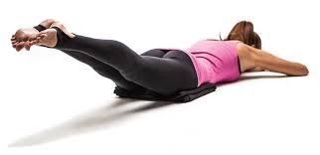

Yoga is a great activity that develops strength, flexibility and can also alleviate stress. While maintaining the yoga pose make sure you are breathing and not holding your breath. Breath deeply in and out. Try holding the position for 30 seconds. Keep track each day to try and increase how long you can maintain it without tiring.

Cat

